RemoteIntern
Remote Internship Progress Dashboard

DIAGRAMS

Submitted by
KUBER SINGH
B2255R10106234
Semester:[VIII]
Under The Guidance of Approval by
Mr.…………….. Dhruv Pandey | Trainee (SME)
(MP ONLINE) MPOnline Ltd.

Department of Computer Science & Engineering
Faculty of Engineering and Technology
AKS University, Satna (M.P.)

📘 Introduction
This document provides the complete technical and functional specifications for the Internship Progress Dashboard project. It serves as the single source of truth for the system's architecture, data modeling, use cases, and deployment strategy, ensuring an industry-level, professional standard.

Project Overview
The Internship Progress Dashboard is a modern, full-stack web application designed to centralize and streamline the management of internship tasks and performance. It facilitates clear communication and measurable progress tracking between interns and their mentors.

Purpose
The primary purpose is to move away from scattered spreadsheets and emails to a unified digital workspace that provides:

- Transparency: Real-time visibility into task status and individual intern performance.
- Efficiency: Automated task assignment, report submission, and feedback loops.
- Data-Driven Decisions: Centralized analytics for mentors to assess program success and intern performance accurately.

Target Users
The system is designed for two primary, distinct user roles, each with specific permissions and views:
Role Primary Focus Key Actions

Intern (User) Task completion and self-tracking
Admin/Mentor Oversight, management, and review
View/Update Tasks, Submit Reports, View Feedback.
Assign Tasks, Review Reports, Provide Feedback, Monitor Analytics.

🎯 System Overview
The system is structured around core functionality that supports the full lifecycle of an intern's assignment, from task delegation to final performance review.

Features Summary
- Secure Authentication: JWT-based login and role-based access control (RBAC).
- Kanban Task Management: Intuitive drag-and-drop interface for tracking task status.
- Report Submission: Structured forms for submitting required project reports and attachments.
- Real-time Analytics: Visual dashboards for performance metrics and progress tracking.
- Feedback Loop: Dedicated system for mentors to provide feedback on tasks and reports.

Modules
The application is logically divided into five core modules:

- User Module: Handles user registration, login, profile management, and role assignment.
- Task Module: Manages the creation, assignment, status updates, and tracking of tasks.
- Report Module: Manages the submission, storage, and retrieval of intern-submitted documents.
- Feedback Module: Facilitates communication by allowing mentors to leave structured feedback and comments.
- Analytics Module: Aggregates data from other modules to generate performance metrics and visualizations.

țț Use Case Diagram
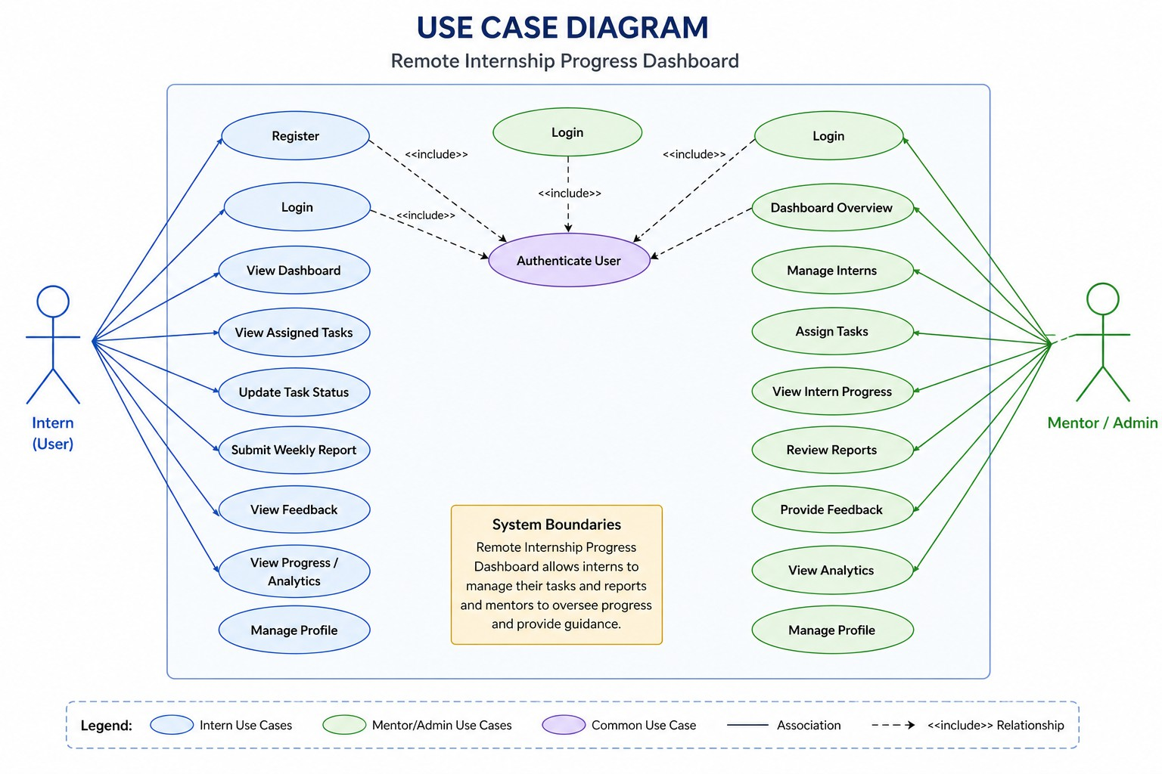
The Use Case Diagram below illustrates the functional boundary of the system and the core interactions of the two user roles.

Intern Actions (Task Update, Report Submission)
- View/Update Tasks: The Intern can view their assigned tasks and change the task status (e.g., from 'To Do' to 'In Progress').
- Submit Reports: The Intern can access the report submission form and attach necessary files to complete the task cycle.
- View Feedback: The Intern can see specific feedback left by the Admin/Mentor on their submitted reports or completed tasks.

Admin/Mentor Actions (Assign Task, Review Reports)
- Assign Tasks: The Admin/Mentor can create new tasks and assign them directly to specific interns.
- Review Reports: The Admin/Mentor accesses submitted reports, reviews the content, and marks them as approved or requiring revision.
- Provide Feedback: This is the core communication action, allowing structured comments and performance ratings to be given.
- View Analytics: The Admin/Mentor can access the performance dashboard to monitor overall program health and individual intern metrics.

Authentication Flow
- Login: Both user roles must successfully authenticate via the /login endpoint to access any core system functionality. This includes validating credentials and issuing a JSON Web Token (JWT).

🔄 Data Flow Diagram (DFD)
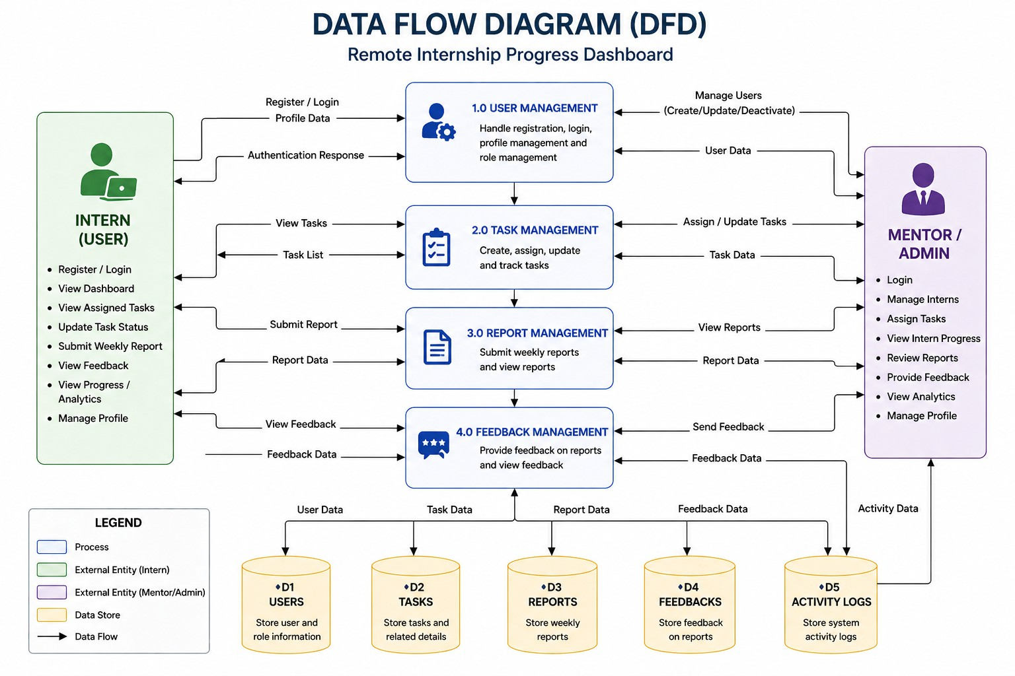
The Data Flow Diagram (DFD) below details the flow of information across the system's processes, entities, and data stores.

User Management
- Process: Handles user registration and profile updates.
- Flow: Intern/Admin inputs profile data, which is processed and stored in the Users data store. The flow ensures role-based data integrity.

Task Management
- Process: Manages task creation, assignment, and status updates.
- Flow: Admin/Mentor assigns tasks (writes to Tasks). Interns retrieve tasks (reads from Tasks) and update status (writes back to Tasks).

Report Management
  - Process: Handles report submission and review.
  - Flow: Intern submits reports (writes to Reports and Attachments). Admin/Mentor retrieves reports (reads from Reports) and initiates the Feedback Flow.

Feedback Flow
  - Process: Manages mentor-to-intern communication.
  - Flow: Admin/Mentor reads reports and writes feedback (to Feedback). Intern reads feedback (from Feedback). This data is often logged in the Logs data store for audit purposes.

Data Stores

Data Store | Primary Data | Purpose
Users | User credentials, profiles, roles. | Authentication and authorization.
Tasks | Task details, status, due dates, assignee IDs. | Workflow and progress tracking.
Reports | Submission metadata, review status. | Documentation and compliance.
Feedback | Mentor comments, ratings, revision notes. | Performance review and communication.
Logs | System activities, audit trails. | Security and troubleshooting.

🗃 Entity Relationship Diagram (ER Diagram)
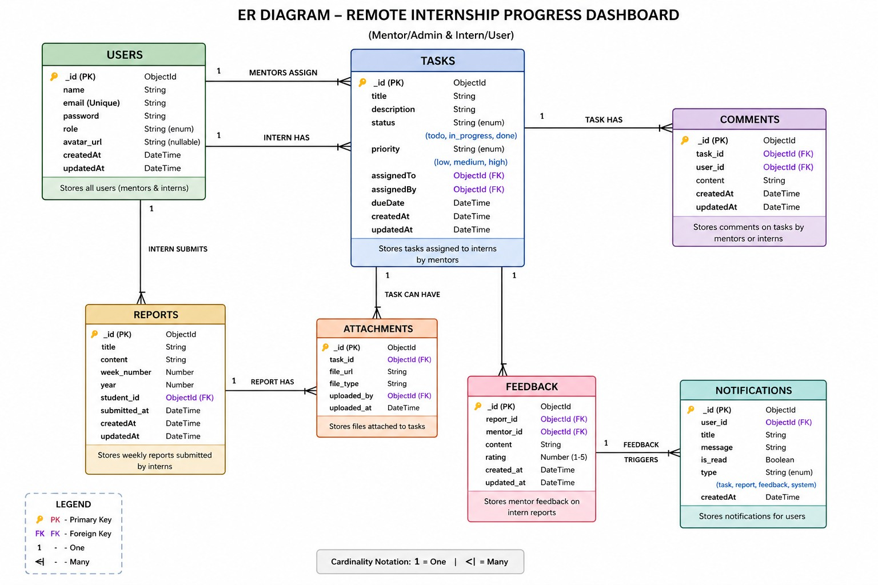
The ER Diagram defines the logical structure of the database, showing entities and the relationships between them.

Entities
- Users: Stores basic user information, including role (Intern or Admin/Mentor) and authentication details.
- Tasks: Represents an individual assignment with attributes like title, description, status, and dueDate.
- Reports: Represents an official submission by an Intern, linked to a specific Task.
- Feedback: Structured review comments and ratings provided by an Admin/Mentor on a Report or Task.
- Comments: Detailed text-based discussions associated with Feedback or Tasks.
- Attachments: Stores metadata for files (e.g., PDFs, zips) submitted with a Report.

Relationships (One-to-Many Mappings)
- User to Tasks (1:N): One Admin/Mentor can assign many Tasks. One Intern can be assigned many Tasks.
- Task to Reports (1:N): One Task can require and receive multiple Reports (e.g., initial and revised submissions).
- Report to Feedback (1:N): One Report can receive multiple Feedback entries from different Admins/Mentors.
- Report to Attachments (1:N): One Report submission can contain multiple attached files.

ObjectId Referencing
The system utilizes MongoDB, where relationships are established via ObjectId
referencing:

- The Tasks entity contains the assignedToUserId (Intern) and assignedByUserId (Admin/Mentor) fields, linking back to the Users collection.
- The Reports entity references the taskId and submittedByUserId.
- The Feedback entity references the reportId and mentorId.

🧩 Sequence Diagram
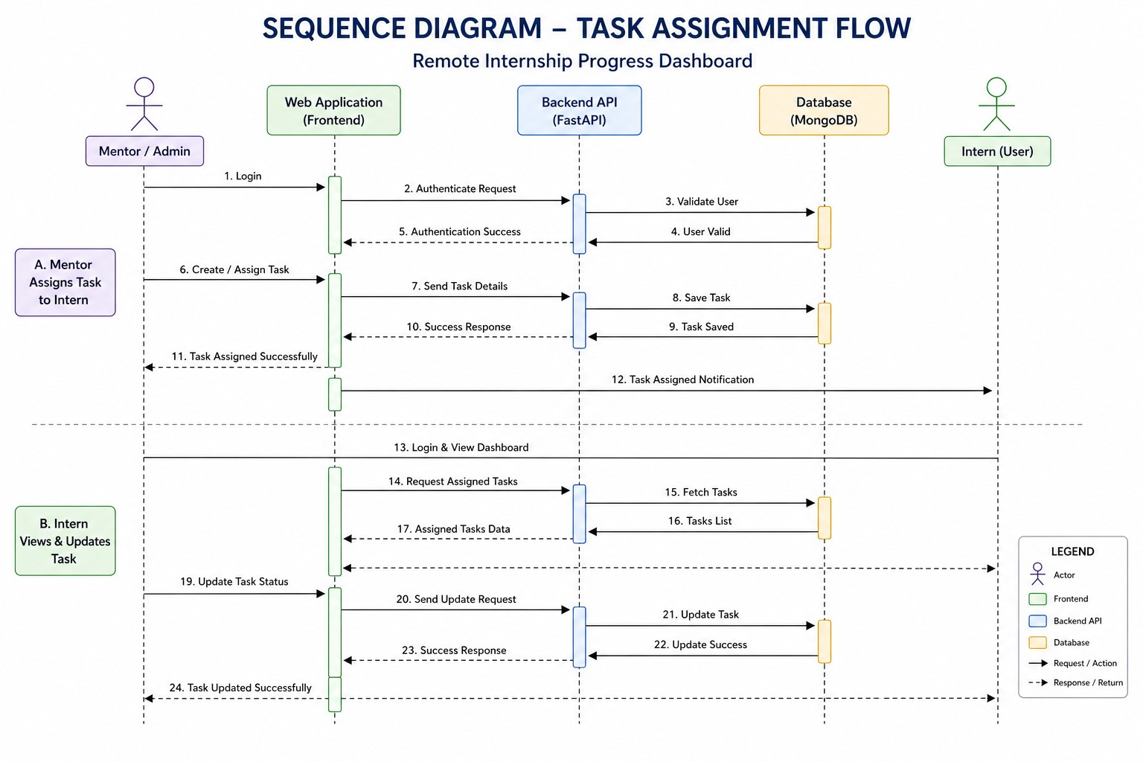

The Sequence Diagram visually traces the flow of logic and communication between the system's components (Frontend, Backend API, Database) during critical user interactions.

Login Flow
- Frontend → Backend: User sends credentials via POST /login.
- Backend → DB: Backend queries the Users collection to validate credentials.
- DB → Backend: Database returns user data.
- Backend: If valid, the Backend issues a JSON Web Token (JWT) containing the user's ID and role.
- Backend → Frontend: JWT is returned to the client for subsequent authorized requests.

Task Assignment Flow
- Frontend → Backend: Admin/Mentor sends task details via POST /tasks.
- Backend: Backend middleware verifies the user's role (RBAC Check).
- Backend → DB: Backend constructs and persists the new task document in the
Tasks collection.
- DB → Backend: Database returns the created task ID/object.
- Backend → Frontend: The newly created task object is returned.

Task Update Flow
- Frontend → Backend: Intern updates a task status via PATCH /tasks/{id}.
- Backend: Backend verifies the Intern is authorized to update the specific task.
- Backend → DB: Backend updates the status field for the task document in the
Tasks collection.
- DB → Backend: Database confirms the update.
- Backend → Frontend: The updated task object is returned to the Intern.

API Interaction (Frontend → Backend → DB)
All application logic and data persistence operate through this three-tier pattern:

  - The Frontend (React) initiates actions.
  - The Backend (FastAPI) handles business logic, security (RBAC), and orchestrates data access.
  - The Database (MongoDB) handles data storage and retrieval.

🏗 System Architecture Diagram
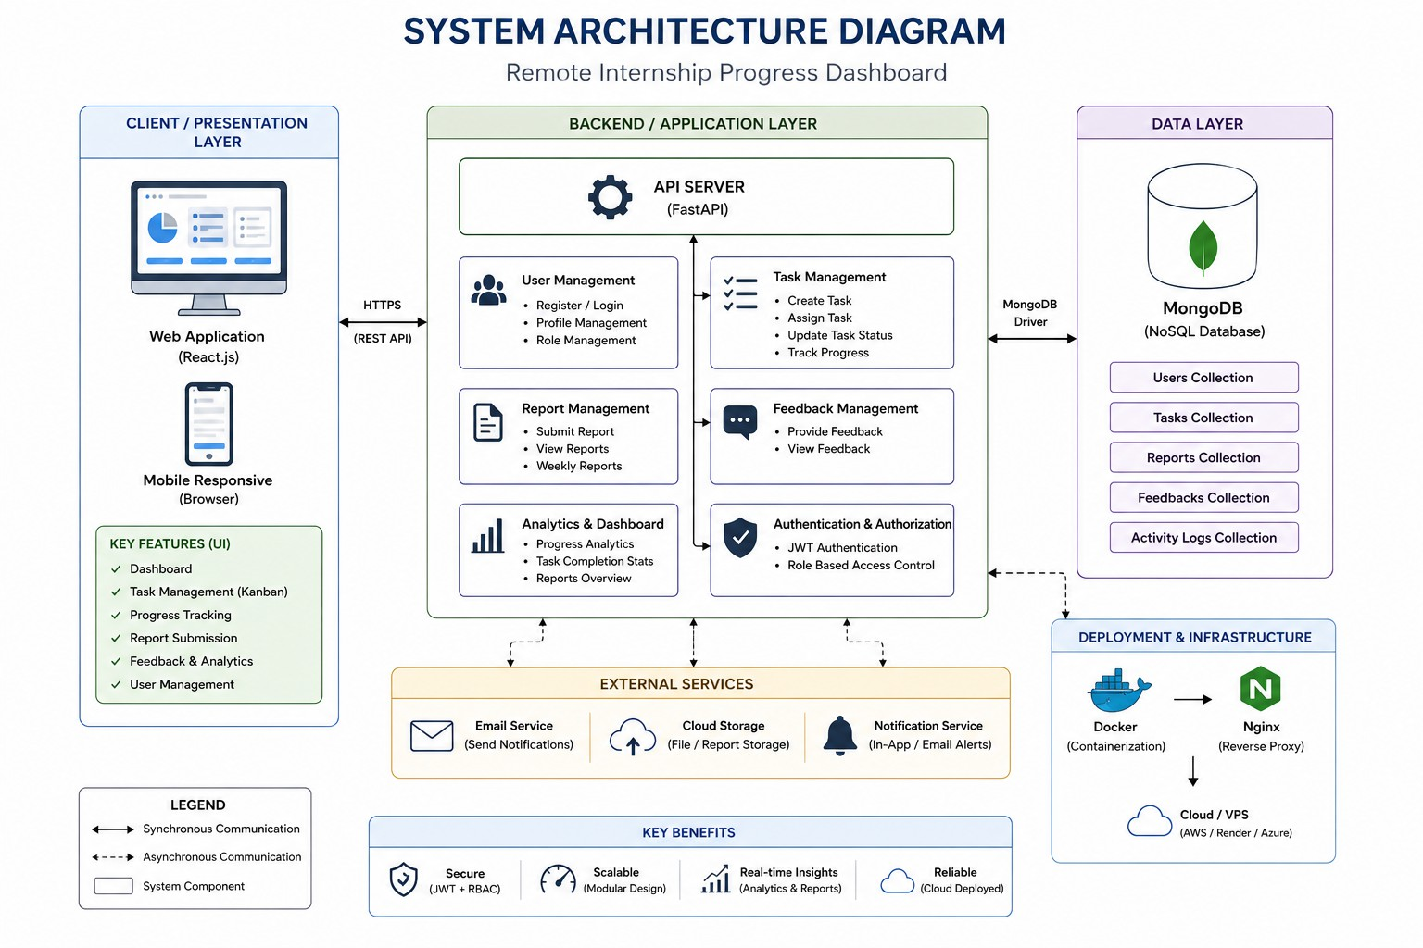
The System Architecture Diagram illustrates the deployment environment and the technological stack used to build and deploy the application.

Frontend (React)
  - Technology: Built using React with TypeScript for a highly maintainable and performant user interface.
  - Deployment: Static files are served via a Content Delivery Network (CDN) for low-latency global access.
  - Interaction: Communicates exclusively with the Backend via RESTful API calls.

Backend (FastAPI)
  - Technology: Built using Python's FastAPI framework for high-speed, asynchronous API development.
  - Function: Handles all business logic, authentication, authorization (RBAC), and data access layers.
  - Containerization: Packaged into a lightweight Docker container for environment consistency.

Database (MongoDB)
  - Type: NoSQL document database.

  - Deployment: Utilizes MongoDB Atlas (cloud-hosted service) for scalability, high availability, and secure connections.
  - Efficiency: Chosen for its flexibility in handling evolving document schemas and its performance for read-heavy operations (e.g., Analytics).

External Services
  - The Backend integrates with third-party services (e.g., SendGrid, AWS SES) for critical functions.
  - Use Case: Sending email notifications for task assignment, due date reminders, or feedback availability.

Deployment (Docker + Cloud)
  - The entire application stack (Frontend, Backend) is containerized with Docker.
  - Containers are deployed to a Cloud Compute Platform (e.g., AWS EC2, Google Compute Engine) for a reliable, scalable hosting environment.

⚙ System Modules Explanation
Each module is responsible for a specific domain within the application, ensuring separation of concerns and maintainability.

User Management
  - Purpose: Securely manages all user identities and roles.

Functionality:
    - Secure JWT-based login and session management.
    - Profile update for both Interns and Admin/Mentors.
    - Admin/Mentor tool for creating new user accounts and assigning initial roles.

Task Management
  - Purpose: The core workflow system for assignments.

Functionality:
    - Admin/Mentor task creation, including description, due date, and priority.
    - Intern Kanban interface for drag-and-drop status changes.
    - API endpoint for retrieving all tasks assigned to a specific user.

Report Management
  - Purpose: Structured submission and storage of project documentation.

Functionality:
    - Intern can submit a report linked to a specific Task ID.

    - Supports file uploads (handled via the Attachments entity).
    - Status tracking: Submitted, Under Review, Needs Revision, Approved.

Feedback System
  - Purpose: The primary communication channel for performance reviews.

Functionality:
    - Admin/Mentor can leave granular feedback on reports or task performance.
    - Feedback includes a rating system (e.g., 1-5 stars) and detailed comments.
    - Interns receive immediate visibility into new feedback.

Analytics Dashboard
  - Purpose: Provides data visualization for performance oversight.

Functionality:
    - Real-time metrics: Task Completion Rate, Average Time-to-Complete, On-Time Submission % per Intern.
    - Visualizations: Progress distribution (Donut Chart) and historical performance trends (Line Chart).
    - Accessible only to the Admin/Mentor role.

🔐 Security Overview
Security is implemented at multiple layers, focusing on data integrity and authorization.

JWT Authentication
  - Process: After login, a secure, time-limited JSON Web Token (JWT) is issued.
  - Usage: Every subsequent API request must include this token in the
Authorization header.
  - Benefit: Stateless authentication ensures the backend remains decoupled from session management, improving scalability.

Role-Based Access Control (RBAC)
  - Implementation: Middleware on the Backend (FastAPI) checks the role
encoded in the JWT before processing a request.

Restrictions:
    - Interns are restricted to read-only access on the /users (except their own profile) and write-access only on their assigned tasks and reports.

    - Admin/Mentors have full CRUD (Create, Read, Update, Delete) privileges on tasks, user accounts, and report review endpoints.

Data Protection
  - Encryption: All sensitive data (e.g., passwords) are stored securely using salted hashing algorithms (e.g., Argon2 or Bcrypt).
  - HTTPS: All communication between the Frontend and Backend is enforced over HTTPS (TLS/SSL) to prevent man-in-the-middle attacks.

📈 Scalability G Performance
The architectural choices were made to ensure the application can handle a growing number of interns and tasks without degradation.

Efficient Database Queries
  - Indexing: Critical fields (e.g., userId, taskId, status) in the MongoDB collections are indexed to optimize read operations, especially for the Analytics dashboard.
  - Aggregation: Performance-intensive analytics calculations utilize MongoDB's native aggregation pipeline for fast, server-side data processing.

Modular Backend
  - The Backend is built with FastAPI's router system, allowing for clean separation of concerns (e.g., task_router, user_router).
  - This modularity allows individual components to be optimized, scaled, or
replaced independently.

Cloud Deployment
  - Deployment on cloud infrastructure (e.g., AWS, GCP) allows for seamless horizontal scaling (adding more instances of the FastAPI server) under high load.
  - The use of MongoDB Atlas provides built-in database sharding and replica sets for performance and fault tolerance.

🚀 Deployment Overview
The deployment strategy is built on modern DevOps principles for consistency and rapid iteration.

Docker Setup
  - Backend: A Dockerfile defines the environment for the FastAPI application, ensuring all dependencies are packaged consistently.
  - Frontend: The React application is built into static assets, and often served via a lightweight Nginx container or directly from a Cloud CDN.

Cloud Hosting
  - The Docker containers are hosted on a Cloud Compute instance or a container orchestration service (e.g., Kubernetes, ECS).
  - CI/CD Pipeline: Automated pipelines are used to build the Docker images, run tests, and deploy the new images to the cloud environment, ensuring rapid, safe releases.

API Communication
  - The Frontend configuration points directly to the Backend API endpoint URL.
  - A reverse proxy (e.g., Nginx or the Cloud Load Balancer) manages traffic, handles SSL termination, and routes requests to the correct Backend server instances.

🔮 Future Enhancements
The following features are planned to expand the platform's capabilities and enhance the user experience.

Notifications:
    - A centralized, real-time notification system (using WebSockets) for instant alerts on new feedback, task assignments, or approaching deadlines.

AI Recommendations:
    - Integrate an AI model to suggest optimal task assignments based on intern workload and historical performance data.
    - Automated detection of performance risks based on time-to-completion metrics.

Real-time Updates:
    - Implement WebSockets on the Kanban Board to allow Admin/Mentors to see task status changes instantly as Interns update them, without page refresh.

Dark/Light Mode:
    - Introduce a user-selectable theme toggle to improve accessibility and cater to diverse user preferences.

